**Detailed Report on Analysis of Cooking Sessions and Order Trends**

**1. Introduction**

This report provides comprehensive insights into user behaviors, preferences, and demographics based on the merged data from user details, cooking sessions, and order details. The analysis focuses on the following aspects:

* Most popular dishes cooked and ordered.
* Demographics of users (age and favorite meal preferences).
* The relationship between cooking sessions and orders.
* Key business recommendations to optimize user engagement and satisfaction.

**Data Report**

**1. About the Data**

The merging process involved three datasets:

* **UserDetails**: Contains information about users, such as user ID, name, age, location, and favorite meals.
* **CookingSessions**: Includes details of cooking sessions, such as session ID, user ID, dish name, and duration.
* **OrderDetails**: Records details about orders, including session ID, dish name, order quantity, and order ID.

**2. Merging Process**

1. **Merge CookingSessions and OrderDetails**:
   * Performed an outer join on the session_id column to retain all records from both datasets.
   * Ensured the user_id column was preserved by re-associating it from the CookingSessions dataset when necessary.
2. **Merge with UserDetails**:
   * Performed an outer join on the user_id column to combine the merged CookingSessions-OrderDetails dataset with UserDetails.
   * Ensured all users were included, even if they had no associated cooking sessions or orders.

**3. Final Dataset**

The final dataset integrates user details, cooking sessions, and order details, providing a complete view of user activities. It includes columns like:

* **User Details**: user_id, user_name, location, etc.
* **Cooking Session Details**: session_id, dish_name, duration, etc.
* **Order Details**: order_id, dish_name, order_quantity, etc.

This unified dataset enables better analysis of user behavior, preferences, and order trends.

**2. Popular Dishes**

**Top 5 Cooked Dishes**

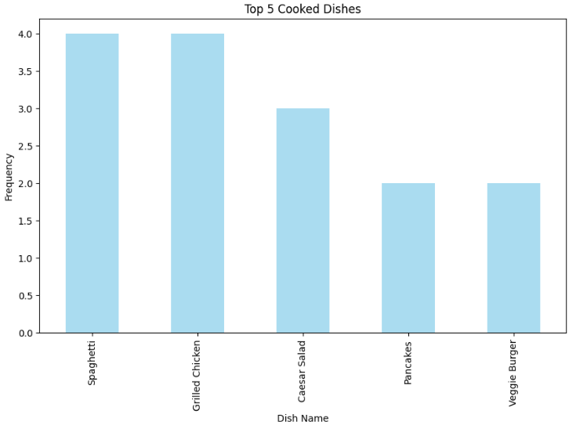

The analysis of the most cooked dishes from the cooking session data reveals the following:

* **Spaghetti**: Cooked 4 times.
* **Grilled Chicken**: Cooked 4 times.
* **Caesar Salad**: Cooked 3 times.
* **Pancakes**: Cooked 2 times.
* **Veggie Burger**: Cooked 2 times.

These results reflect user preferences for simple, versatile, and popular dishes that are easy to prepare at home.

**Top Cooked vs. Ordered Dishes**

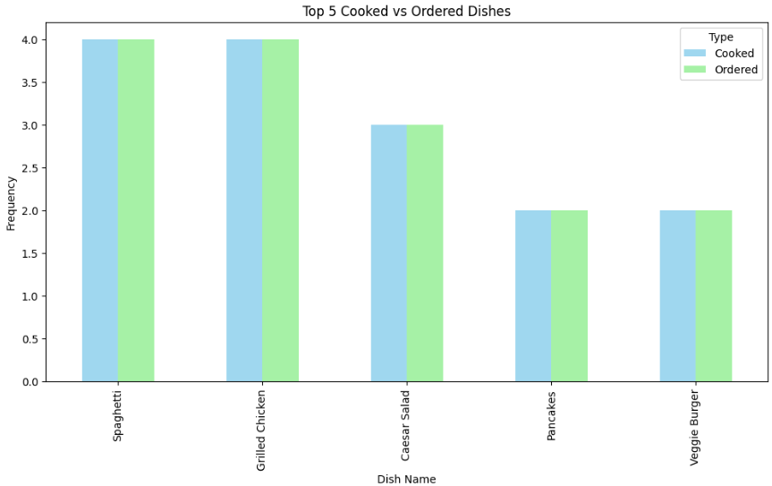

The data highlights a strong alignment between the most cooked and most ordered dishes:

* **Spaghetti** and **Grilled Chicken** dominate both categories, showcasing their consistent popularity.
* Dishes like **Caesar Salad** are cooked more frequently than ordered, suggesting they are considered easier to prepare at home.
* On the other hand, dishes ordered more frequently than cooked may indicate their complexity or users’ preference for convenience.

**Key Insight**: Understanding the gap between cooked and ordered dishes presents an opportunity to provide tailored recipes, meal kits, or promotional offers for dishes that users find challenging to prepare.

**3. User Demographics**

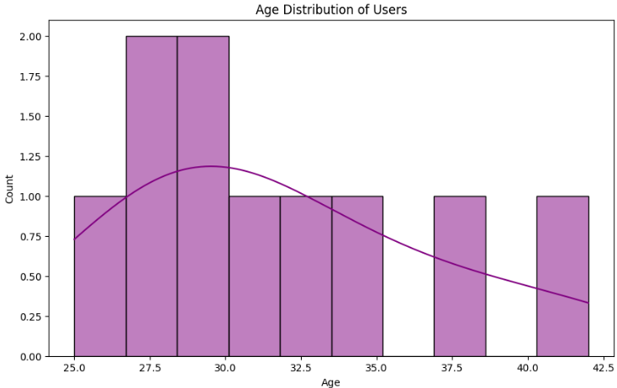

**Age Distribution**

The age distribution of users provides the following insights:

* **Mean Age**: 31.8 years.
* **Age Range**: 25 to 43 years.
* **Standard Deviation**: 5.27 years.

A histogram analysis reveals that the majority of users fall into the late 20s to early 30s, representing the core user demographic actively engaging with the platform.

**Age Distribution Across Favorite Meals**

The boxplot analysis of favorite meals indicates the following:

* **Lunch** is heavily favored by younger users (21–30 years).
* **Dinner** is popular among users in their late 20s, with preferences showing a compact distribution.
* **Breakfast** is predominantly favored by older users (around 40 years), with a wider distribution.

**Key Insight**: Meal preferences vary significantly by age group, which can guide the platform’s marketing and menu customization strategies.

**4. Correlation Between Cooking Sessions and Orders**

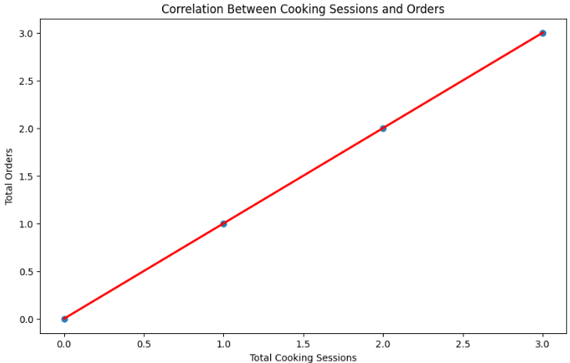

The analysis reveals a strong positive correlation between the number of cooking sessions and total orders placed. This suggests that users who actively participate in cooking sessions are more engaged with the platform and more likely to place orders.

**Key Insight**: Encouraging users to join cooking sessions can boost engagement and order frequency, driving overall platform activity.

**Favorite Meal Preferences by Age Group**

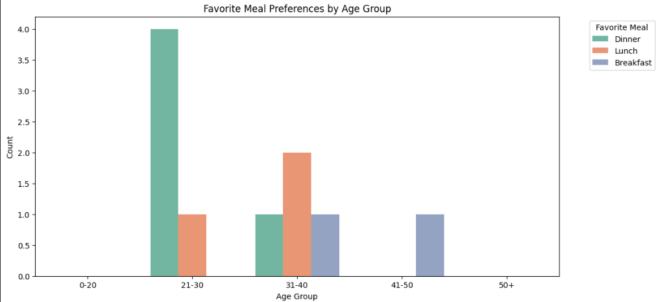

The chart illustrates the meal preferences across different age groups:

* **21–30 Age Group**: This group dominates the user base and shows a pronounced preference for **lunch**, making it the most popular meal choice within this demographic.
* **31–40 Age Group**: Preferences for **dinner** rise significantly, showcasing a balanced distribution between lunch and dinner in this segment.
* **41–50 Age Group**: The focus shifts toward **breakfast**, indicating a trend toward healthier or earlier meal choices as users age.
* **50+ Age Group**: Representation in this group is notably lower, highlighting an opportunity to engage this demographic with tailored campaigns and offerings.

The boxplot in the image depicts the age distribution across different favorite meals (Dinner, Lunch, and Breakfast). Here’s a breakdown of the interpretation:

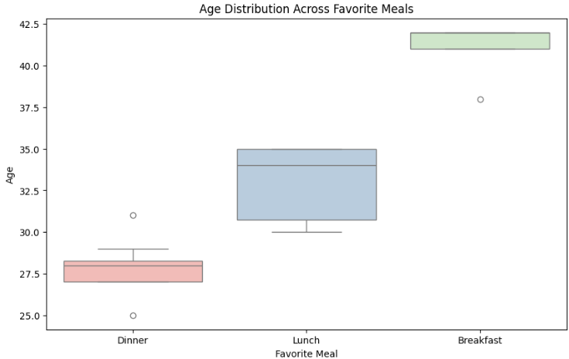

1. **Dinner**:
   * Median Age: Approximately 27.5 years.
   * Range: Ages are tightly clustered between 26 to 28.5 years.
   * Outliers: There are two outliers below 26 years and one above 30 years.
2. **Lunch**:
   * Median Age: Around 32.5 years.
   * Range: Ages vary more compared to Dinner, approximately from 30 to 35 years.
   * No significant outliers observed within the given range.
3. **Breakfast**:
   * Median Age: Around 40 years.
   * Range: The ages are consistently high compared to the other meals.
   * One noticeable outlier is above 42 years.

**General Observations:**

* Individuals who favor **Breakfast** are generally older compared to those who prefer **Lunch** or **Dinner**.
* Age distribution for **Dinner** is more compact with less variability.
* **Lunch** has a moderate spread, while **Breakfast** has the highest age range among the three categories.

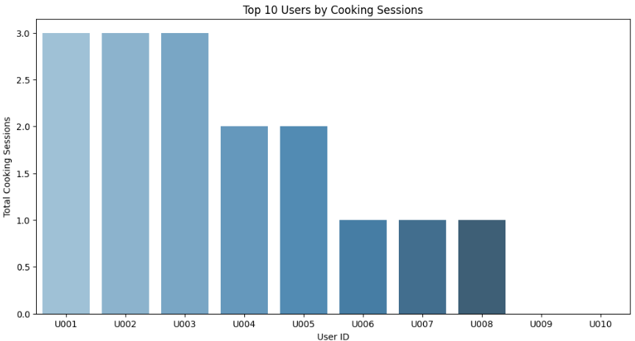

1. **Top Users by Activity**

A small subset of highly active users contributes significantly to cooking sessions and orders:

* The **top 10 users** account for a disproportionately high number of cooking sessions.
* These users demonstrate high loyalty and engagement, making them ideal candidates for brand ambassadors or advocates for the platform.

**Key Insight**: Recognizing and rewarding these users can strengthen their loyalty while inspiring others to increase their activity levels.

**6. Key Insights**

1. **Cooking vs. Ordering Preferences:**
   * **The alignment between top cooked and ordered dishes suggests opportunities for recipe tutorials and simplified meal kits.**
   * **Addressing gaps where dishes are more frequently ordered than cooked can help users overcome preparation challenges.**
2. **Demographic Trends:**
   * **The core demographic (21–40 years) shows distinct preferences for lunch and dinner.**
   * **Older users favor breakfast, representing a potential growth segment.**
3. **Engagement and Loyalty:**
   * **Users with more cooking sessions are significantly more likely to place orders, highlighting the value of interactive engagement.**
   * **Top users can be leveraged as influencers or ambassadors.**

Business Recommendations

1. **Meal Customization and Marketing**
   * Target younger users (21–30 years) with lunch promotions and meal bundles. Younger users show a strong preference for lunch, making this a prime focus for targeted marketing.
   * Develop breakfast-specific campaigns to attract older users (40+ years). Breakfast is favored by older demographics, representing an opportunity for growth.
2. **Engagement Strategies**
   * Promote cooking sessions with incentives, such as discounts on future orders or exclusive recipes. Cooking sessions encourage user activity and engagement, which correlates with higher order frequency.
   * Offer loyalty rewards for top users to enhance advocacy and retention. Recognizing and rewarding active users builds loyalty and can motivate others to increase their activity levels.
3. **Addressing Cooking Challenges**
   * Provide step-by-step tutorials and pre-measured ingredient kits for complex dishes. Simplifying complex recipes can increase user confidence in cooking.
   * Highlight convenience in ordering for dishes that are more challenging to prepare at home. This can help convert users who prefer ordering into active participants in cooking sessions.
4. **Expanding the User Base**
   * Focus on attracting older users (50+ years) through tailored meal plans, simplified cooking sessions, and health-oriented menu options. Older users are underrepresented but could be engaged through health-conscious and easy-to-prepare meal options.
5. **Engage Highly Active Users**
   * Introduce loyalty programs or rewards for the top users to encourage sustained engagement. This group contributes significantly to activity and orders, making them valuable for advocacy.
   * Offer personalized meal kits or discounts for these users to increase order volume.
6. **Expand Reach in Underrepresented Age Groups**
   * Design marketing campaigns targeting the 50+ age group, emphasizing convenience and health benefits.
   * Provide content and meal plans that cater to this demographic's unique needs (e.g., simplified recipes or health-conscious options).
7. **Optimize Menu Based on Preferences**
   * Focus on promoting dishes that are both popular to cook and order, as they align closely with user preferences.
   * Simplify the preparation process for dishes that are ordered more frequently than cooked to encourage more cooking sessions.
8. **Enhance Meal Recommendations**
   * Use the insights from age group preferences to personalize meal suggestions.
   * For example, suggest lunch options prominently to users aged 21–30 or dinner options for older age groups.
9. **Leverage Correlation Between Sessions and Orders**
   * Encourage more cooking sessions by providing free or discounted trial sessions for new users.
   * Highlight the ease of ordering ingredients for dishes cooked in sessions to convert cooking users into ordering customers.
10. **Popular Dishes and Promotions**
    * Focus on promoting dishes like Spaghetti and Grilled Chicken through campaigns and offers. These dishes are popular, making them ideal for marketing.
    * Time-Based Promotions: Target high-activity periods (e.g., evenings) with special discounts or loyalty rewards.
    * Low Engagement Users: Offer incentives like free trials or bonuses for users in the "low engagement" cluster to increase activity.
    * Meal Preferences: Launch new menu items aligned with dinner preferences, which dominate user activity.
    * Ratings-Based Insights: Highlight high-rated dishes in marketing campaigns to attract users seeking quality.

**8. Conclusion**

By implementing the strategies outlined in this report, the platform stands to achieve the following key outcomes:

* + **Enhanced User Engagement and Satisfaction**: By aligning services with user preferences and addressing their challenges, the platform can create a more personalized and fulfilling experience.
  + **Increased Order Frequency and Revenue Growth**: Leveraging cooking sessions, targeted promotions, and loyalty programs can drive higher engagement and transaction rates.
  + **Expansion into New Market Segments**: By tailoring offerings to underrepresented demographics, such as the 50+ age group, the platform can broaden its customer base and capture untapped potential.
  + **Stronger Brand Loyalty**: Rewarding top users and actively engaging with the community fosters trust and long-term advocacy.